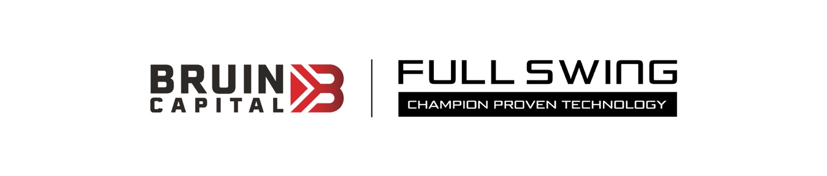
Embargoed until Monday, July 26, 8:00 a.m. US EDT.
Contact: For Bruin Capital, Scott Novak snovak@bruincptl.com

Bruin Capital To Acquire State of the Art Sports Technology Company: Full Swing

NEW YORK, NY/Carlsbad, CA (7.26.21) – Bruin Capital (Bruin/@Bruin_Cap) has reached an agreement with North Castle Partners to acquire controlling interest in Full Swing (FS), the Carlsbad, CA-based sports technology and performance company. North Castle will remain a shareholder, and the new alliance will accelerate FS's global expansion and the introduction of new consumer products and gaming businesses in golf and other sports. It comes as on and off-course golf participation is growing at record levels and as more fans are turning to interactive sports training and entertainment experiences overall.

Full Swing is the industry's largest producer of multi-sport simulators for commercial, residential, and entertainment venues offering 13 unique sports experiences. PGA TOUR pros, including Tiger Woods, 2021 U.S. Open Champion, current world No. 1 ranked golfer Jon Rahm, and three-time major champion Jordan Spieth, use the simulator for training purposes. Full Swing simulators are also the centerpiece of
long-term exclusive relationships with the PGA TOUR and Golf Channel. In addition, you'll find FS simulators in Topgolf Swing Suites nationwide through another long-term partnership. What differentiates FS simulators from others is its patented dual-tracking technology, software that delivers instantaneous data analytics, and best-in-class graphics.

"Full Swing set the standard for authentic simulator experiences in golf. With great vision, the team also developed leading-edge software and technological capabilities that will translate into more in and out-of-home product lines across more sports for all levels of athletes, enthusiasts, and casual fans. In doing so, Full Swing is very well-positioned to capitalize on the exploding interest in compelling, interactive experiences and subscription-based gaming services," said George Pyne, Bruin Capital Founder & CE0 - @GFPyne on Twitter.

"We at Full Swing pride ourselves on delivering the most authentic and accurate golf experience indoors and soon to be outdoors in the world. We couldn't be more enthusiastic with the investment, partnership, and most of all experience that Bruin brings to the table as we look to expand our product portfolio and global reach,” said Ryan Dotters, Full Swing CEO.

"We are excited to be part of the new Bruin – Full Swing partnership. We believe Bruin's expertise in this industry coupled with Full Swing's extraordinary management team and our knowledge and network will continue to drive growth through innovation and excellence," added Alison Minter, North Castle Managing Partner.

Later this year, FS will begin shipping its highly anticipated "Full Swing KIT" a state-of-the-art launch monitor inspired and developed in consultation with Tiger Woods. From capabilities to price point, the Full Swing KIT could be an industry game-changer. It is a data-rich device delivering premium performance for golfers of all levels. The capabilities, essential information, and analytics were all directed by Woods. The Full Swing KIT is portable for indoor & outdoor use, combining machine learning enhanced radar and a 1080P HD camera to generate immediate data intelligence accessible via personal devices' across the digital ecosystem.

Joining Woods, Rahm, and Spieth as Full Swing ambassadors who use the equipment for training and contribute to product development include former World No. 1 and 2015 PGA Champion Jason Day, 2019 U.S. Open Champion, Gary Woodland, 2012 FedExCup Champion Brandt Snedeker, 2013 US Open Champion and 2018 FedExCup Champion, Justin Rose; 2018 PGA TOUR Rookie of the Year Aaron Wise; the LPGA's Brooke Henderson, the all-time winningest Canadian Golfer, 3X NBA Champion and two-time MVP Steph Curry and 2018 NFL MVP and Super Bowl LIV Champion Patrick Mahomes.

This will be the latest acquisition for Bruin Capital, the investment and operating company specializing in building global sports, technology, media, and entertainment companies. On July 12, the company announced the pending acquisition of Oddschecker, the UK's leading betting affiliate, and media company. In March, Bruin took joint ownership of TGI Sport, the global sports technology and marketing company. Bruin also owns, Deltatre, the sports media technology company; Two Circles, the sports fan data, and analytics company; Soulsight, the brand strategy and design company; and Engine Shop, the sports and entertainment marketing company. Collectively they operate across five continents, with a combined and their work has won hundreds of awards and serve billions of consumers worldwide.

# # #

About Bruin Capital: Bruin Capital @Bruin_Cap/www.bruincptl.com) is an international investment and operating company founded by George Pyne @GFPyne. Bruin specializes Bruin specializes in working with capital partners and management teams to build best-in-class, global technology, sports, media, entertainment, and marketing companies. Bruin companies currently operate across five continents with 2100 employees working out of 34 offices. Bruin investors include The Jordan Company, CVC Capital Partners, Rock Ventures, NNS Chaired by Nassef Sawiris, and a prestigious group of family investment funds..

About Full Swing: Full Swing is the largest US-based producter of golf and sport simulators, chosen as the Official Licensee of PGA Tour and the Official Simulator of Golf Channel, it is the only simulator giving players patented dual-tracking technology to provide unmateched real ball flight. Users can dynamically experience more than 13 sports including golf, featuring the world’s most iconic golf courses. Team Full Swing Boasts PGA Tour players Tiger Woods, Jon Rahm, Justin Rose, Jordan Spieth, Gary Woodland, Brandt Snedecker, Jason Day, the LPGA’s Brooke Henderson, the NBA’s Steph Curry and the NFL’s Patrick Mahomes.

About North Castle Partners: North Castle Partners is a leading private equity firm focused on investments in consumer-driven product and service businesses that promote healthy, active, and sustainable living. North Castle is a hands-on, value-added investor in high-growth, middle-market companies in the (i) fitness, recreation & sports, (ii) nutrition, (iii) beauty & personal care, (iv) consumer health, and (v) home & leisure sectors, among others. North Castle partners with management to bring a wide range of strategic and operational capabilities to build world-class companies by unlocking the exponential power of full potential partnerships. North Castle is headquartered in Greenwich, CT. For more information, visit www.northcastlepartners.com.

